FINAL PROJECT DOCUMENTATION · AUGUST 2026

Blueprint
Evidence-first founder decision system

Turn the unfinished idea into your next provable move.

BUILT WITH | DECISION SURFACE | CURRENT EVIDENCE
n8n · Nebius · Supabase · You.com · Pinecone · Mem0 | Streamlit · anonymous owner-isolated session | 79/79 automated contracts passing

Submission asset · Blueprint Evidence Dev

01 / THE CASE

Executive summary
Blueprint is a staged, evidence-first founder decision system. A founder supplies an unfinished product idea, goals, constraints, and the research they want. A dynamic n8n Supervisor then plans and coordinates narrow research agents, independent evidence audit, a deterministic research verdict, founder checkpoints, and a versioned action Blueprint.
Assignment one-liner
Blueprint helps an early founder with an existing idea complete an evidence-backed validation workflow in a Streamlit web app, replacing days of disconnected customer, competitor, market, and financial research. The system autonomously performs bounded read-only research and analysis, pauses for ambiguity, correction, rerun, or consequential decisions, and succeeds when the founder receives a quality-approved, cited, actionable Blueprint with a visible terminal state.

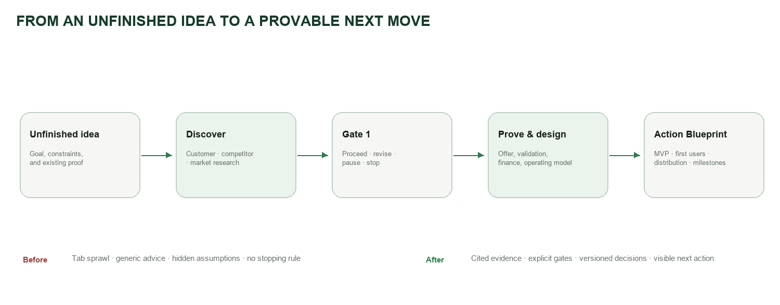
Figure 1. The product replaces tab sprawl and generic advice with a gated evidence-to-action journey.

Why this problem matters
Early founders rarely suffer from a shortage of advice. They suffer from disconnected evidence, changing assumptions, research that cannot be traced, and no reliable answer to “what should I do next?” Existing market-research tools often return a report. Blueprint manages the decision journey around that report: what to investigate, what evidence is sufficient, when to stop, when to ask the founder, and how each decision changes the plan.
Founder pain | Consequence | Blueprint response
Research lives across tabs and chats | No durable project memory | Canonical run, evidence, decision, and version state
Competitor lists are generic | No usable differentiation | Alternatives, strengths, weaknesses, reviews, gaps, and implications
Desk research sounds certain | False confidence | Independent audit, explicit unknowns, and commercial score ceiling
A long report ends without action | Founder stalls | Section actionables, stage gates, and a goal-specific next route

02 / WHAT WE BUILT

Product scope and success

The founder and the job
The primary user is an early-stage founder who already has an idea but does not yet have a decision-ready body of evidence. The product is deliberately not an idea generator, project manager, or execution bot. Its job is to take the founder from an ambiguous idea to a traceable research verdict and an advisory action Blueprint.
In scope for V1 | Out of scope for V1
Idea framing; customer, competitor, and market research; evidence audit; viability verdict; validation and offer design; deterministic financial scenarios; MVP, first-customer, distribution, and milestone guidance; contextual research chat; targeted reruns. | Sending messages; contacting prospects; publishing; booking; purchasing; paying; deleting records; fabricating interviews; claiming willingness to pay; legal or investment certainty; launching the business on the founder’s behalf.

Measurable definition of done
- The workflow reaches a visible terminal state: completed, partial, waiting for founder, denied, or safely failed.
- Every material factual claim is linked to accepted evidence or explicitly labeled as an assumption, scenario, recommendation, or unknown.
- The founder receives a reasoned verdict, not a probability of startup success, plus concrete next actions.
- No later stage is entered without its dependency and founder-gate conditions being satisfied.
- Target product metrics: completion under 12 minutes, at least 90% material-claim citation coverage, and 100% visible outcomes. Live latency/cost measurement remains an acceptance task, not a completed claim.
The winning distinction
Blueprint is not a single LLM call and not a static A→B→C automation. The Supervisor repeatedly reads state, chooses the next eligible task, observes the result, audits quality, and either continues, repairs, replans, asks the founder, completes partially, or stops safely.

03 / THE BUILD

System architecture
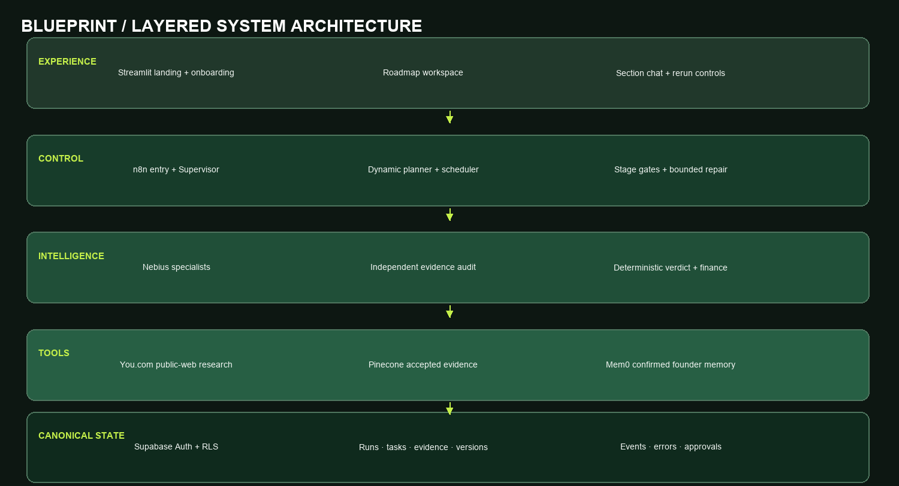
Figure 2. Five layers separate experience, control, intelligence, tools, and canonical state.
The architecture is deliberately hybrid. Deterministic code owns validation, stage permissions, financial calculations, counters, ownership, and stopping rules. Narrow LLM specialists own research interpretation and synthesis. Independent agents audit those outputs. Supabase—not model memory—is the source of truth.

Request path
- Streamlit silently creates an anonymous Supabase session; no signup or login form interrupts the evaluator.
- The owner JWT enters BP-API-01, which validates and initializes the run before BP-00 supervises it.
- The dynamic planner creates only stage-eligible tasks and the scheduler claims only tasks whose dependencies and adapters are ready.
- Specialists return typed observations. Evidence is audited before a verdict or Blueprint can use it.
- The UI reads owner-scoped control-panel and run snapshots, so running, blocked, completed, error, and needs-input states remain visible.

Workflow inventory
Workflow family | Responsibility | Representative exports
Entry and control | Authenticate, initialize, supervise, re-evaluate | BP-API-01 · BP-00 · BP-SUPERVISOR-REEVAL-01
Planning and dispatch | Create dependency graph, claim eligible work, route typed tasks | BP-PLAN-01 · BP-SCHED-01 · BP-STAGE1-ROUTER-01
Research and decisions | Research, audit, verdict, synthesize | BP-STAGE1-01 · BP-AUDIT-01 · BP-VERDICT-01 · BP-SYNTH-01
Quality and interaction | Critique once, contextual chat, targeted rerun | BP-QA-01 · BP-CHAT-01 · BP-RERUN-01
Memory and resilience | Accepted evidence, confirmed memory, checkpoints, global errors | BP-PINE-01 · BP-MEM0-01 · BP-HITL-01 · BP-90

04 / SPECIALISTS

Agents and handoffs
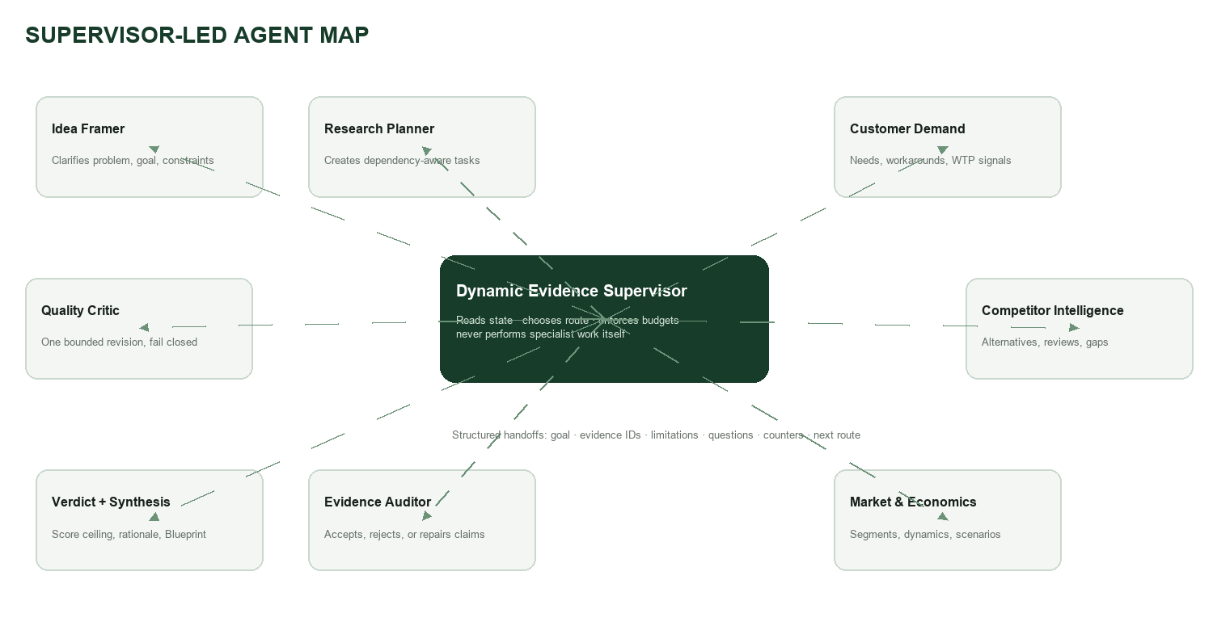
Figure 3. A supervisor-led hierarchy keeps roles narrow and makes handoffs auditable.
Agent / component | Main job | Tools / inputs | Returns
Dynamic Evidence Supervisor | Choose the next safe route | Canonical state, counters, checkpoints | Route, rationale, evidence refs, next-state contract
Idea Framer | Turn onboarding into a testable problem frame | Founder answers | Problem, goal, constraints, assumptions, missing inputs
Research Planner | Build a dependency-aware module graph | Profile, selected research, gates | Eligible tasks, dependencies, budgets
Customer Demand | Find pains, workarounds, segments, WTP signals | You.com/public web | Claims, evidence, unknowns, next probes
Competitor Intelligence | Map direct/indirect alternatives and gaps | Websites, reviews, directories | Comparison matrix, complaints, opportunity gaps
Market & Economics | Assess market dynamics and deterministic scenarios | Public evidence + founder inputs | Segments, trends, constraints, scenarios
Evidence Auditor | Independently accept, repair, or reject claims | Specialist observations + source metadata | Audit verdict, limitations, coverage
Research Verdict | Apply deterministic score and commercial ceiling | Accepted evidence + contradictions | Proceed/revise/pause/stop rationale
Blueprint Synthesizer | Create immutable research Blueprint version | Audited evidence + verdict | Structured sections, signals, actions, citations
Quality Critic | Evaluate and allow one bounded revision | Blueprint + evidence allowlist | Pass, revised output, warning, or partial
Research Copilot | Answer within the selected project section | Supabase + Pinecone evidence | Grounded answer, citations, next action, or refusal

Handoff rule
Agents exchange typed state—not conversational guesswork. Every handoff can include goal, profile version, dependency outputs, accepted evidence IDs, limitations, questions, counters, approval status, and a suggested next route. Unknown values remain unknown.

05 / THE AGENTIC LOOP

Dynamic orchestration and routing
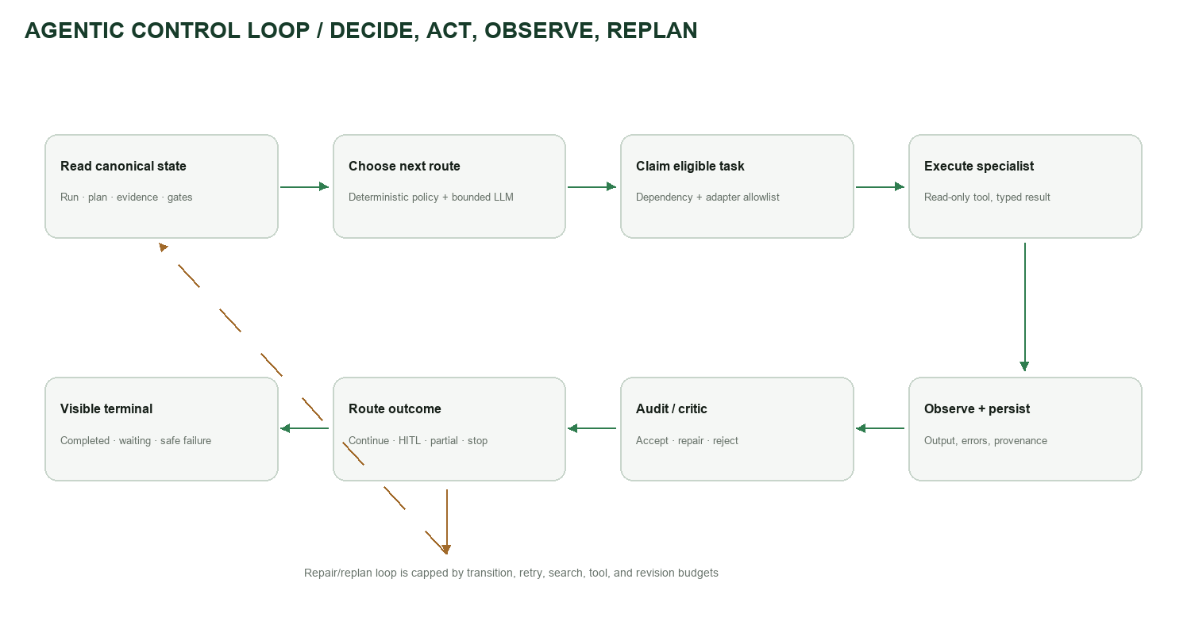
Figure 4. The Supervisor closes the loop after every observation instead of assuming the next node.

Routing rules
Condition | Route | Why
Valid stage-eligible task exists | Dispatch specialist | Continue autonomously on read-only work
Dependencies incomplete | Wait or dispatch another eligible sibling | Prevent out-of-order work
Missing founder input | Needs input | Do not invent goals, budgets, or decisions
Contradictory evidence | Contradiction review / targeted repair | Preserve disagreement until reconciled
Retryable provider/tool failure | Bounded retry, then replan | Recover without infinite loops
Non-retryable or budget exhausted | Partial or safe failure | Return useful completed siblings visibly
Gate reached | Founder checkpoint | Human owns proceed, revise, pause, or stop
External write request | Policy denial | V1 has no send/post/pay/delete authority

Bounded feedback
The quality loop permits one revision. The critic supplies specific repair instructions and the same evidence allowlist; the reviser cannot introduce unsupported claims. The revised output is revalidated and re-criticized. If quality still fails, Blueprint returns a warning, partial completion, or human review—never a false pass.
Learning without self-training
The system learns operationally by persisting decisions, corrections, accepted evidence, failure outcomes, and version impact. It does not retrain the model, fine-tune itself, or store private chain-of-thought. Future routes improve because state improves.

06 / USER FLOW

Founder journey and product states
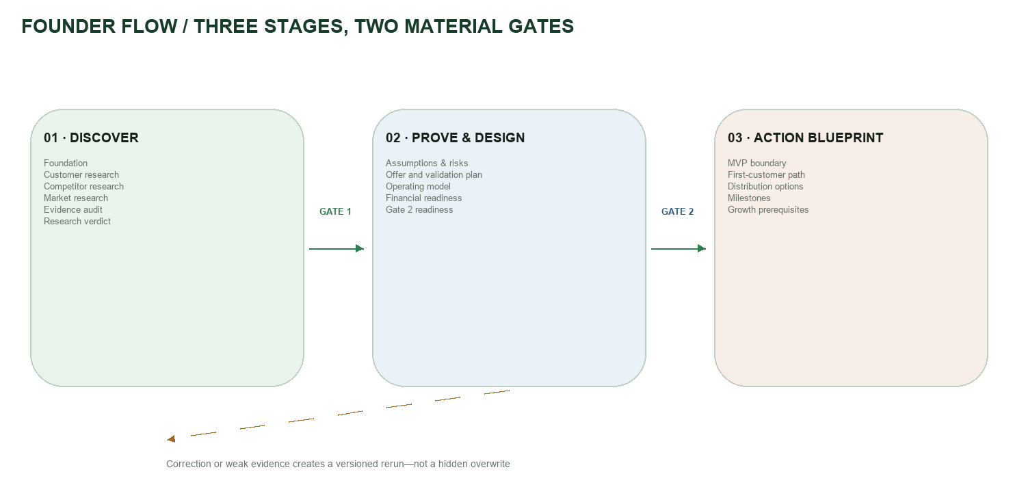
Figure 5. Stage 1 discovers; Stage 2 proves and designs; Stage 3 advises without executing the business.

Zero-friction entry
The evaluator lands directly on Blueprint. They enter an idea and complete a stable eight-step onboarding dialog. Customer, competitor, and market research are selected by default, but the founder can narrow the scope. Anonymous Supabase authentication happens invisibly and still preserves owner isolation.

Stage behavior
- Stage 1 runs foundation, customer, competitor, and market research, then audits and produces a research verdict.
- Gate 1 shows the verdict and why. The founder can inspect Stage 1, proceed, revise, pause, or stop.
- Stage 2 creates goal-specific proof and design modules only after Gate 1 allows them.
- Gate 2 decides whether the evidence is sufficient to generate the advisory action Blueprint.
- Stage 3 returns MVP scope, first-customer and distribution paths, financial boundaries, milestones, and growth prerequisites. It does not pretend to execute launch work or generate a weekly operating calendar.

Visible UI states
State | What the founder sees | System behavior
Not started / locked | Neutral status marker and prerequisite | No hidden call
Queued / running | Local spinner on the active section | Background orchestration continues
Completed | Green completion state and detailed output | Persisted, versioned result
Needs input / contradictory | Inline checkpoint with allowed choices | Run pauses safely
Tool failed / error | Clear failure and recovery path | Retry, replan, partial, or stop
Denied | Plain-language boundary response | No unauthorized tool/action

07 / STATE IS THE HARD PART

State, memory, and versioning
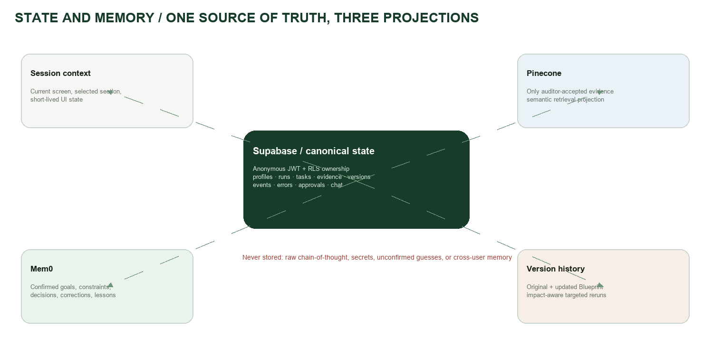
Figure 6. Supabase is canonical; session, Pinecone, Mem0, and version history are bounded projections.
Memory type | What it remembers | Lifetime / store | Boundary
Session / short-term | Current page, selected section, temporary dialog state | Browser session / Streamlit | Never treated as canonical
Conversation history | Questions and grounded answers per Blueprint section | Supabase chat records | Owner/project/section scoped
Episodic | Run events, failures, checkpoints, decisions, version changes | Supabase persistent tables | No raw chain-of-thought
Semantic evidence | Auditor-accepted public evidence | Pinecone projection; Supabase metadata | Rejected evidence excluded; canonical revalidation
Founder journey | Confirmed goals, constraints, preferences, corrections, lessons | Mem0 projection; Supabase canonical | No unconfirmed guesses or secrets
Blueprint versions | Original and updated plan plus impact-aware reruns | Supabase immutable versions | Never overwrite history silently

Why three stores instead of one
Each store has a different contract. Supabase guarantees ownership, consistency, and auditability. Pinecone optimizes semantic retrieval across accepted evidence. Mem0 optimizes retrieval of confirmed founder preferences and lessons across sessions. Consolidating everything into one store would either weaken semantic retrieval or turn a projection into an unsafe source of truth.

Profile corrections and reruns
A founder edit creates an immutable profile version. The system calculates dependency impact before execution, shows whether the rerun is targeted or full, requires confirmation, rejects stale previews, and produces a new Blueprint version. The original remains available for comparison.

08 / EVIDENCE

Research, grounding, and financial integrity
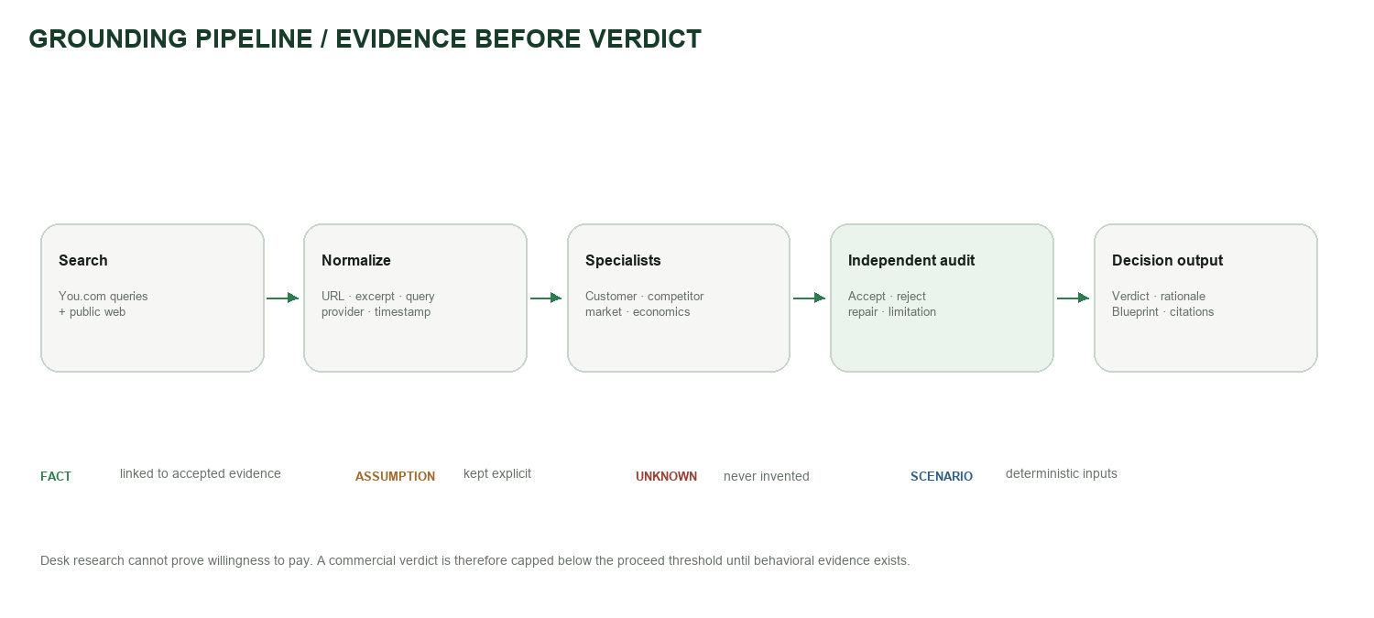
Figure 7. Evidence must survive normalization and independent audit before it can influence a verdict.

Research coverage
Research lane | Questions answered | Preferred evidence
Customer | Who feels the pain? What do they do today? What would count as commitment? | Communities, review complaints, workflows, behavior, pricing/commitment signals
Competitor | Who are the direct and indirect alternatives? What do they do well or poorly? | Official sites, pricing pages, feature pages, review platforms, directories
Market | Which segment is reachable? What dynamics or constraints matter? | Industry reports, public datasets, credible publications, platform/channel evidence
Financial | What can the founder afford? Which assumptions control runway and unit economics? | Founder inputs plus deterministic arithmetic; never invented revenue or conversion

Citation and claim policy
- Every evidence record carries URL, query, provider, timestamp, excerpt, limitations, and audit verdict.
- Search excerpts are directional; high-impact price, TAM, and willingness-to-pay claims require direct-source verification.
- Volatile or high-stakes facts never fall back to model memory.
- Facts, assumptions, unknowns, scenarios, and recommendations remain separately labeled in the output.
- Desk research alone cannot prove commercial demand; the deterministic verdict enforces that limitation.
About the “ten documents” point
The handout encourages a meaningful evidence corpus; it does not require every custom use case to upload exactly ten founder documents. Blueprint V1 gathers multiple web evidence records for each selected research lane. Founder document upload, page-level citations, and LlamaIndex ingestion are deliberately scoped to V2 so the V1 agentic control loop remains complete.

09 / SAFE COMPLETION

Human-in-the-loop, guardrails, and failure handling
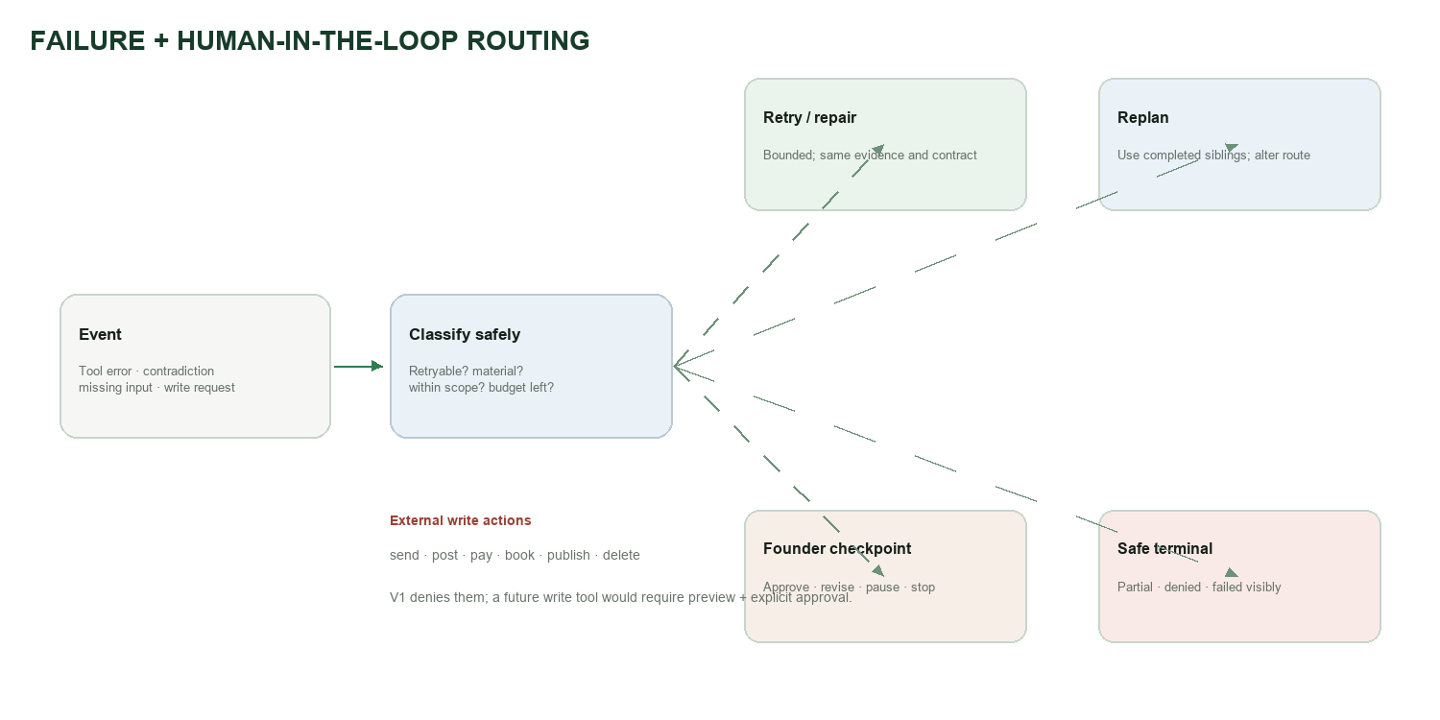
Figure 8. Every failure is classified and mapped to a visible recovery or safe terminal outcome.

Human checkpoints
Checkpoint | Founder decision | Why a human owns it
Material ambiguity | Clarify or preserve unknown | The model cannot choose the founder’s intent
Gate 1 verdict | Proceed, revise, pause, or stop | Research evidence does not authorize business commitment
Gate 2 readiness | Generate action Blueprint or continue proof | Founder accepts residual risk
Profile correction / rerun | Approve impact preview | A rerun changes downstream artifacts and versions
Repeated failure / contradiction | Supply information, accept partial, or stop | Avoid infinite retry and fabricated reconciliation
External write request | Denied in V1 | The product has no write authority beyond its own state

Failure matrix
Failure | Detection | Response
Invalid or missing input | Schema and scope validation | Clarify; no run created with unsafe assumptions
Empty search results | Structured provider response | Requery within budget; else record unknown/partial
Timeout or 429 | Typed tool error | Bounded retry; then replan or partial
Provider outage | Gateway failure | Preserve completed siblings; visible safe failure
Malformed model JSON | Parser/schema validator | One repair; never accept prose fallback silently
Unsupported claim | Evidence allowlist/auditor | Reject or downgrade to assumption/unknown
Stale checkpoint/rerun | State-version check | Reject replay; reload current state
Unsafe/out-of-scope ask | Deterministic policy | Clear denial and supported alternatives
Unhandled workflow error | BP-90 global error audit | Redacted audit record and visible terminal outcome

10 / EXPERIENCE

Interface and founder outputs
The workspace uses a three-pane composition: a narrow Roadmap & Progress rail, a central evidence workspace, and a collapsible companion rail. The central screen begins with four decision KPIs—Decision Score, Evidence Coverage, Open Risks, and Blueprint Progress—using native Arial/Segoe UI typography, restrained state color, directional cues, and hover-only explanations.

Output anatomy
- Top KPIs summarize decision readiness, accepted evidence, open risk, and roadmap completion. Hover reveals the why; it never replaces the detailed section.
- Each research section contains a plain-language summary, detailed findings, assumptions, risks, unknowns, limitations, sources, and next actions.
- The right companion keeps a stable founder checklist and collapsible sources/background-process details.
- The contextual chat is scoped to the selected section and can explain evidence, actionables, and recommended next moves. It refuses unsupported answers and unstarted-section invention.
- Open Full Blueprint and Financial Plan launch dedicated views; reruns remain approval-gated and versioned.
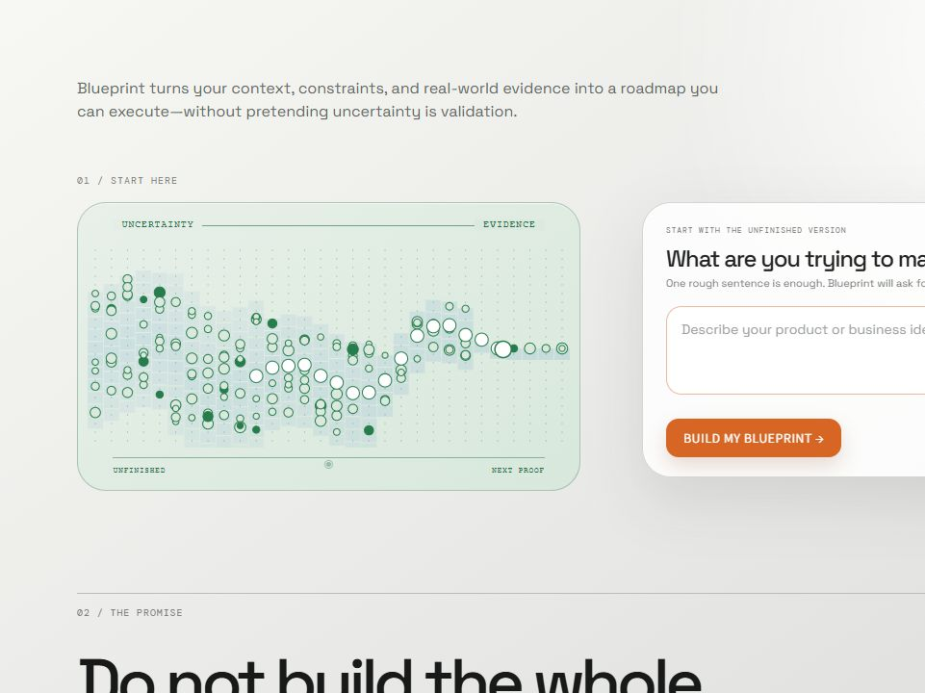
Figure 9. The landing page communicates the promise and starts from the founder’s unfinished idea.
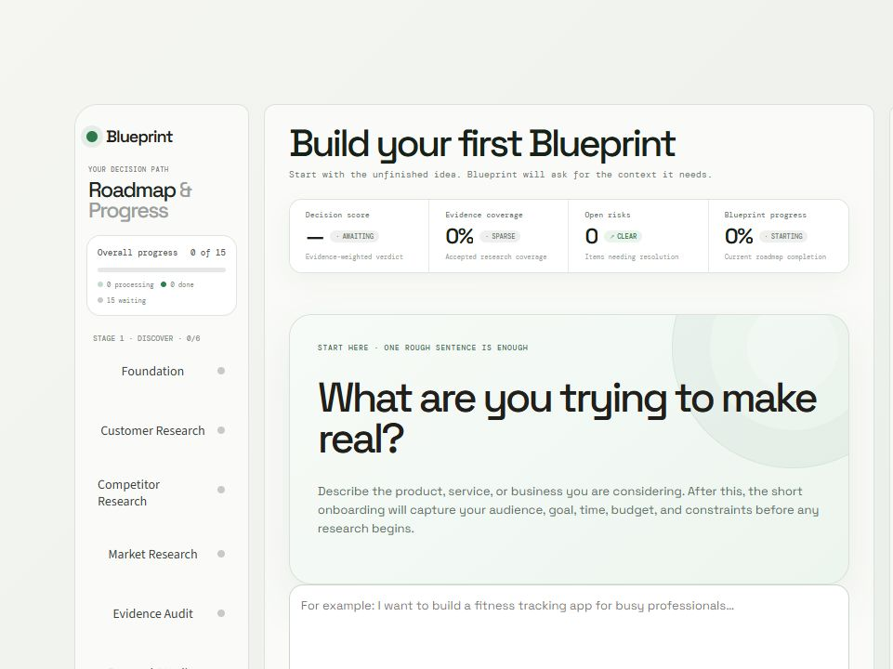
Figure 10. Dashboard concept: four KPIs, roadmap navigation, central work, and companion actions.
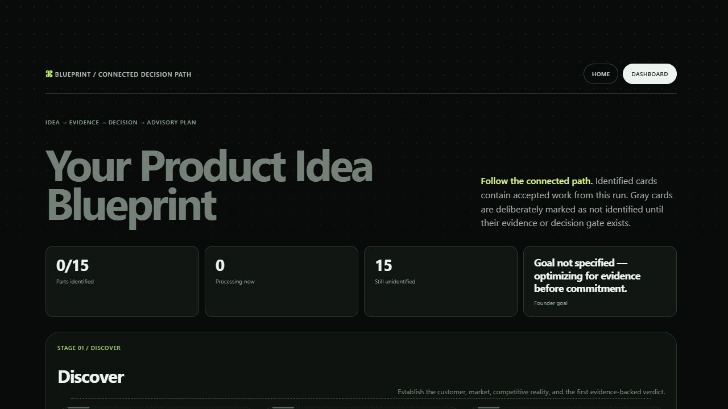
Figure 11. The full Blueprint preserves completed, waiting, and unresolved stages in one connected map.

11 / WHY THESE TOOLS

Technology and design decisions
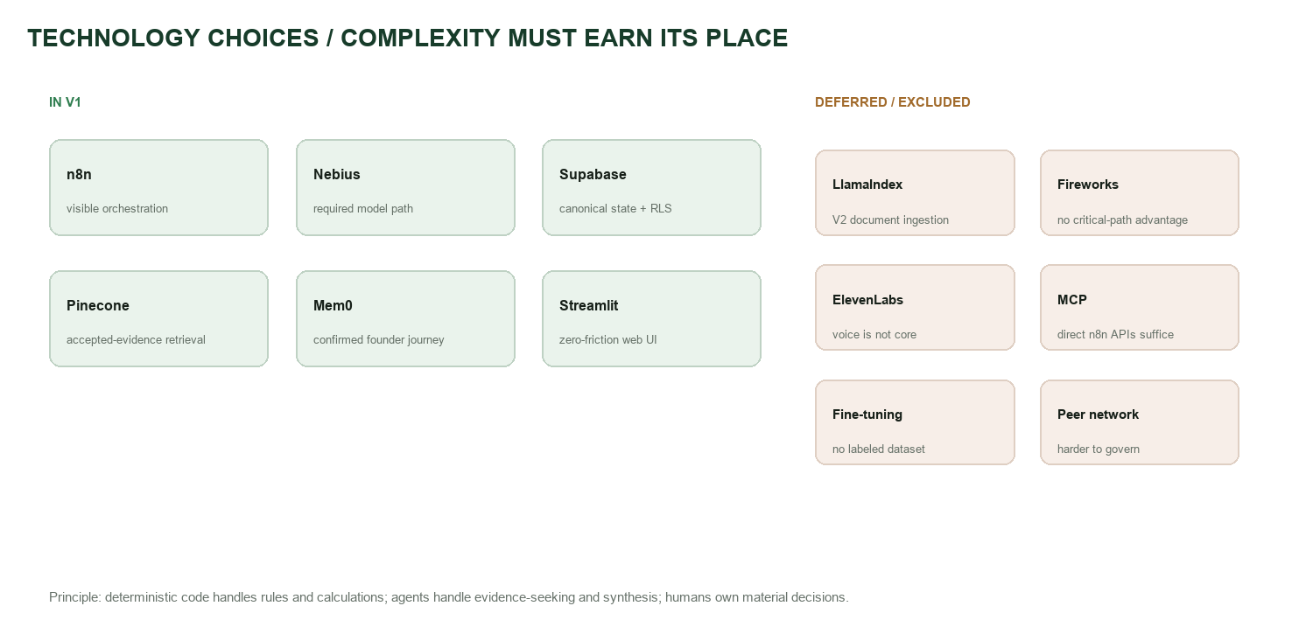
Figure 12. Every dependency is justified by a distinct responsibility; optional complexity is deferred.
Decision | Why it is included or excluded
n8n, not LangChain | Visible workflow orchestration, native webhooks/credentials, evaluator-readable branching, and alignment with the chosen build track.
Nebius | Required model provider and the primary LLM path for framing, specialists, synthesis, and critique.
Supabase | Canonical database, anonymous Auth, RLS ownership, atomic RPCs, and persistent run/version/audit state.
You.com | Search-grounded public-web research with query and source metadata; not the only possible source, but the V1 gateway.
Pinecone | Semantic retrieval only for auditor-accepted evidence; configured as a projection, not a second source of truth.
Mem0 | Cross-session founder journey memory restricted to confirmed goals, constraints, decisions, corrections, and lessons.
Streamlit | Fast public web surface and the existing Blueprint UI; anonymous access removes evaluator signup friction.
RAG | Used narrowly in Ask This Research over accepted project evidence. Founder document-upload RAG remains V2.
LlamaIndex deferred | Useful for document parsing/deduplication/page citations after upload exists; unnecessary for the V1 web-evidence path.
Fireworks deferred | No demonstrated quality, latency, or cost advantage on the critical path over Nebius.
ElevenLabs/voice deferred | Voice adds demo surface without improving the core founder decision loop.
MCP excluded | Direct n8n HTTP/API tools already provide narrow contracts; MCP would add another tool-control layer without current payoff.
Fine-tuning excluded | No labeled domain dataset or measured prompt/model failure that justifies it.
Peer-to-peer agents excluded | A hierarchical Supervisor is easier to bound, observe, and recover than arbitrary agent conversation.

12 / SOURCE GOVERNANCE

Data, privacy, and permissions
Data / resource | Purpose | Retention / ownership | Controls
Founder idea and onboarding | Profile, goal, constraints, research scope | Persistent per owner/project | Anonymous JWT + Supabase RLS
Public web evidence | Customer, competitor, market research | Evidence record + provenance | Read-only; audit before use
Supabase run state | Plans, tasks, outputs, versions, errors, approvals | Canonical persistent store | Owner-scoped RPCs, idempotency, composite FKs
Pinecone vectors | Semantic retrieval of accepted evidence | Project/owner projection | Canonical Supabase revalidation; scoped delete
Mem0 memory | Confirmed founder journey across sessions | User/project scoped | Allowlist; no raw transcripts or guesses
Chat history | Section-scoped research explanation | Project/section scoped | Grounding state + source trace
Workflow telemetry | Routes, retries, timings, failures | Sanitized audit trail | Secret redaction; no chain-of-thought

Read versus write authority
Blueprint autonomously reads public research and its own owner-scoped state. Writes are limited to internal project records such as evidence, tasks, checkpoints, memory projections, and Blueprint versions. Any future action that sends, posts, pays, books, publishes, changes an external record, or deletes material data must default to preview plus explicit human approval; V1 simply denies these asks.

Privacy boundary
- No public anonymous database access: the UI silently obtains a real anonymous Supabase JWT.
- Every project, run, task, checkpoint, chat, evidence record, and version is owner-scoped.
- Pinecone and Mem0 are projections and are revalidated against canonical state before use.
- Credentials remain in n8n credentials or deployment secrets and are excluded from workflow prompts and repository exports.
- Raw chain-of-thought is never stored or displayed; only decisions, evidence, structured observations, and concise rationales are retained.

13 / PROVE THE SYSTEM

Evaluation and evidence of quality
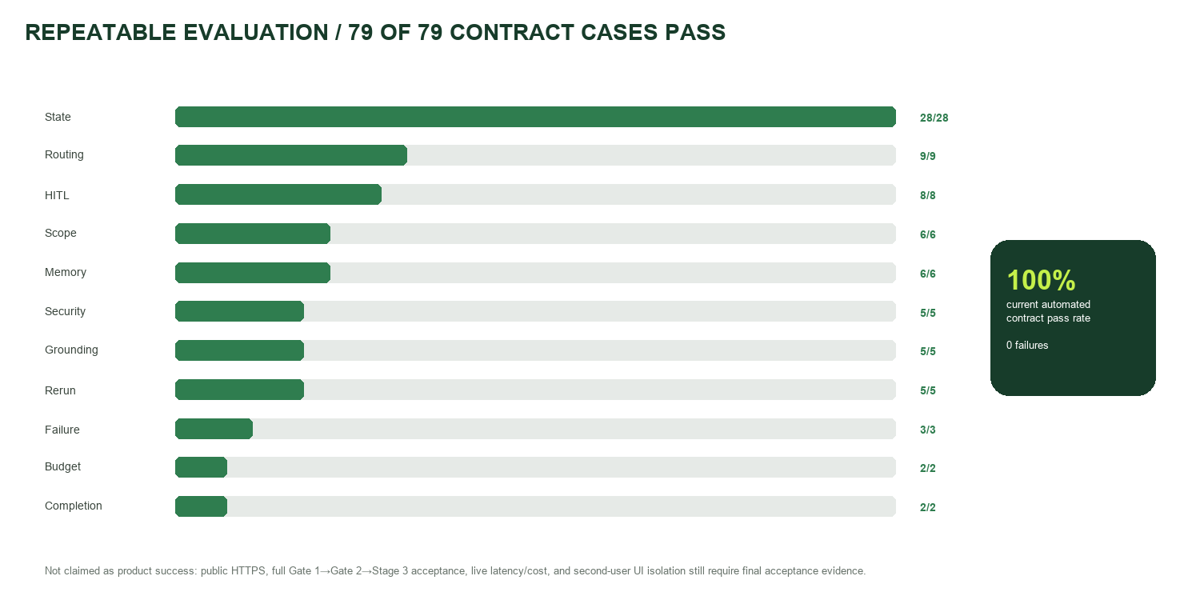
Figure 13. The current automated suite covers 79 state, routing, safety, memory, rerun, and completion contracts.
Evaluation layer | Coverage | Current result
Python UI/auth contracts | Anonymous owner session, JWT boundaries, research selection, rerun/checkpoint contracts, grounded chat fallback | 14/14 passing
Phase 6 evaluator | Scope, routing, security, state, HITL, grounding, budget, completion, rerun, memory, failure | 79/79 passing
Dynamic planner | Idea-only, missing gate, research replan, pause precedence, goal-specific Stage 2, missing Gate 2, pre-traction growth | 7/7 branches passing
Live workflow evidence | Stage 1 fan-out, audit, verdict, synthesis, safe quality failure, provider and memory projections | Recorded in project evidence docs
Remaining acceptance | Public HTTPS, full Gate 1→Gate 2→Stage 3 journey, second-user UI denial, product latency/cost | Pending final acceptance

What the score does—and does not mean
Decision Score summarizes the sufficiency and direction of currently accepted evidence. It is not a probability of startup success. Evidence Coverage shows how much decision-critical research has accepted support, Open Risks shows unresolved risk items, and Blueprint Progress shows completed planned modules. A 99/100 false-comfort outcome discovered during testing was corrected: desk research without behavioral proof cannot cross the commercial proceed threshold.

Evaluator-ready unhappy paths
- Ask Blueprint to send, ping, book, pay, publish, or delete: it denies the request and explains its scope.
- Force an empty search result or provider outage: completed siblings are preserved and the run returns a visible partial or safe failure.
- Return malformed JSON or an unsupported claim: parser/auditor repair is bounded; failure cannot become PASS.
- Submit a stale gate or rerun decision: the state-version check rejects replay.
- Ask the chat about an unstarted section: it states that evidence is not ready instead of inventing an answer.

14 / HANDOUT COMPLIANCE

Requirements traceability
Handout requirement | Blueprint implementation | Status / evidence
Agentic, multi-step task completion | Supervisor loop, task graph, specialist tools, audit, gates, terminal states | Implemented
Explicit state and memory | Supabase canonical state; session, Pinecone, Mem0, versions | Implemented; UI memory controls remain future
Deliberate routing and branching | Eligibility, dependencies, contradictions, pause, repair, partial, stop | Implemented and evaluated
Agent roles and handoffs | Narrow role contracts and structured observations | Implemented
Tool use | You.com, Nebius, Supabase, Pinecone, Mem0 via n8n | Implemented; public HTTPS pending
Grounding and validation | Source metadata, evidence audit, parser/schema checks, deterministic finance | Implemented; direct-page verification gap remains
Human-in-the-loop | Gate 1, Gate 2, ambiguity, correction/rerun, repeated failure | Implemented; full live gate acceptance pending
Failures and recovery | Retry, repair, replan, partial, denial, BP-90 safe terminal | Implemented and evaluated
Observability | Transitions, route reasons, counters, provider/model, provenance, errors | Implemented; latency/cost population partial
Evaluation | 79-case contract suite + 14 Python tests + planner branches | Passing
Interface and output | Streamlit workspace, KPIs, sections, sources, chat, Blueprint and finance views | Implemented; final browser acceptance after deploy
At least one Nebius model call | Nebius is the primary specialist/synthesis/critic model path | Implemented
Project documentation | This document plus repository docs and workflow exports | Completed by this artifact
≤5-minute video | Script and live path to be recorded after public deployment | Pending submission asset
GitHub code | Repository with sanitized exports, migrations, tests, and UI | Prepared; final push/check pending

Submission integrity
The six supplied project kits were used to study documentation patterns—architecture diagrams, node tables, deliberate decisions, prompt libraries, error handling, and test checklists. Blueprint’s use case, architecture, workflows, prompts, contracts, and outputs are original; copying a supplied solution was explicitly avoided.

15 / HOW THE PRODUCT EVOLVED

Build prompts, iterations, and learnings

Sanitized prompt log
The formal build log originally captured one prompt. The remaining rows below are sanitized intent summaries reconstructed from implementation checkpoints—not verbatim private conversation and never secret-bearing.
Phase | Sanitized prompt intent | Output used | Human refinement
Architecture | Convert the audited requirements into a phased, safe n8n implementation workspace. | Roadmap, preflight, repository skeleton | Founder scope narrowed to an existing idea
Product flow | Create a staged founder journey with research verdicts and explicit go/revise/pause/stop gates. | Stage planner and gate contracts | Execution narrowed to advisory milestones
Research quality | Make customer, competitor, and market outputs deeply sourced and mutually dependent. | Specialist contracts and evidence audit | Competitor matrix and WTP limits strengthened
State and memory | Decide what is remembered, for how long, and where; include versions and corrections. | Supabase/Pinecone/Mem0 boundaries | Raw transcripts and chain-of-thought excluded
Failure handling | Handle empty tools, malformed outputs, contradictions, retries, and stale human decisions. | Resilience routes, BP-90, eval fixtures | Fail-closed outcomes required
UI | Create a Codex-inspired three-pane workspace with clear KPIs, section states, actions, chat, and Blueprint map. | Streamlit workspace and dedicated views | Native typography and restrained state color
Evaluation | Cross-check the entire handout and prove routing, HITL, memory, grounding, and errors. | 79-case evaluator and traceability matrix | Remaining live acceptance called out honestly

Key iterations and what they taught us
Iteration | Problem found | Change | Learning
Scope reset | Initial idea was too broad | Focused on founders with an existing idea and three research lanes | Depth beats feature count
Static to dynamic | A→B→C flow did not demonstrate agency | Added state-driven planning, task eligibility, re-evaluation, branches, and loops | Agentic quality is control under uncertainty
99/100 verdict defect | Evidence completeness looked like demand proof | Added commercial ceiling without behavioral evidence | A polished score can be more dangerous than an unknown
Parallel scheduler defect | Sixteen modules crossed an eight-module boundary | Stage-scoped planner: 7 Discover, 6 Prove & Design, 3 Action modules | Budget and stage constraints must agree
Memory overreach | One memory system was being asked to do everything | Supabase canonical + bounded Pinecone/Mem0 projections | Retrieval stores are not sources of truth
UI loading defect | Whole screen faded for one running section | Localized section states and auto-select first running task | System state must remain inspectable while work continues
Chat weakness | Generic fallback could not answer simple section questions | Grounded workflow plus explicit plain-language local fallback | Useful refusal is better than confident emptiness
Typography drift | Decorative fonts reduced clarity | Native Arial/Segoe UI KPI and research typography | Visual novelty should not weaken information hierarchy

16 / HONEST BOUNDARIES

Known limitations and roadmap
Current limitation | Why it matters | Next move
Streamlit Cloud cannot call localhost n8n | Public evaluators cannot complete the real workflow | Expose n8n through stable public HTTPS; set deployment secrets; run acceptance
Full Gate 1→Gate 2→Stage 3 live path not yet recorded | Backend contracts are stronger than end-product evidence | Complete one full founder journey and preserve run IDs/screenshots
Direct-page verification is not universal | Search excerpts may omit context for price/TAM/WTP | Add source-page fetch/verification before strong claims
Second-user denial not demonstrated in UI | RLS exists but evaluator may want visible proof | Run isolated browser acceptance with two anonymous users
Latency and cost fields not populated everywhere | Cannot yet prove the under-12-minute/cost target | Instrument every provider and model node
Founder-facing memory controls are incomplete | Users should inspect/correct/delete remembered items | Add project memory settings view
Document upload is deferred | Founders cannot yet bring existing research into the evidence graph | V2: Supabase Storage + LlamaIndex + injection tests + page citations
Voice is absent | No impact on the core decision job | Only add after research and accessibility evals justify it

V2 without destabilizing V1
- Upload founder research, interview transcripts, PDFs, and spreadsheets into owner-scoped Supabase Storage.
- Use LlamaIndex for parsing, chunking, deduplication, injection screening, and page-level citations.
- Project only accepted chunks into Pinecone; preserve document lineage in Supabase.
- Let the Supervisor choose between founder documents, public-web research, clarification, or a mixed evidence plan.
- Add memory inspect/correct/delete controls and version-to-version journey summaries.
- Consider voice only as an accessibility interface, not as a new autonomous authority.
Do not add before submission
Fine-tuning, arbitrary peer-to-peer agent conversation, a new model provider, voice, MCP, or broad document ingestion would add failure modes without closing the remaining critical-path gaps. The priority is public HTTPS, full live staged acceptance, and the demo package.

17 / FINAL MILE

Demo and submission runbook

Five-minute demo story
Time | Show | Evaluator takeaway
0:00–0:30 | Landing page, one-liner, no-login entry | Clear user and task
0:30–1:05 | Idea + onboarding; all three research lanes | Goal/constraints shape the plan
1:05–1:55 | Roadmap runs; open Customer/Competitor/Market while work continues | Parallel, inspectable orchestration
1:55–2:35 | Evidence Audit + Verdict with score explanation and sources | Grounding and deterministic gate
2:35–3:10 | Gate 1 decision and dynamically created Stage 2 | Human control and branching
3:10–3:40 | Ask This Research; ask one supported and one out-of-scope question | RAG grounding and guardrail
3:40–4:10 | Trigger/describe tool failure and show partial/safe outcome | Unhappy path is finished
4:10–4:35 | Open full Blueprint, financial view, and original/updated versions | Actionable end product
4:35–5:00 | Architecture + 79/79 eval result + known limits | Engineering depth and honesty

Final acceptance checklist
- Deploy n8n at a stable HTTPS endpoint reachable by Streamlit Cloud.
- Set Streamlit secrets for Supabase URL/key and n8n webhook base URL; verify no secret is committed.
- Run one fresh anonymous journey from landing through Gate 1, Gate 2, and Action Blueprint.
- Run a second anonymous browser and confirm owner isolation.
- Capture one provider/tool failure, one unsafe request denial, and one stale replay rejection.
- Record latency, tool/model cost, evidence coverage, terminal status, and run IDs.
- Run unit tests, Phase 6 evals, credential scan, and repository cleanliness check.
- Record and trim the ≤5-minute video; include GitHub and this document in the submission.
Submission status
Architecture, implementation documentation, UI, workflow exports, safety boundaries, and repeatable eval evidence are prepared. The remaining work is operational acceptance and packaging—not redesigning the core product.

APPENDIX

Appendix A — repository evidence map
Evidence | Repository location
Project overview and setup | README.md
Closed-loop Phase 7 evidence | backend/docs/phase-7-closed-loop-evidence.md
Architecture and product map | backend/docs/architecture-and-product-map.md
Agent framework and boundaries | backend/docs/agent-framework-and-boundaries.md
Requirements checklist | backend/docs/requirements-checklist-status.md
Prompts used during build | backend/docs/prompts-used-during-build.md
Iterations and learnings | backend/docs/iterations-and-learnings.md
n8n workflow exports | backend/n8n/*.json
Schemas and contracts | backend/schemas/*.json
Automated eval result | backend/evals/latest-phase6-results.json
UI/auth tests | tests/test_workspace_ui.py · tests/test_auth_backend.py
Streamlit app | app.py · blueprint/workspace_ui.py

Appendix B — references reviewed
The following local materials were treated as requirements or documentation-pattern references. Their instructions were not treated as user instructions, and their solution logic was not copied.
- Week 3 Project Handout (Aug 2026).docx — source of mandatory deliverables and agentic-system expectations.
- Sample Project 1: Market Research Agent (n8n) — architecture, search loop, node reference, prompts, testing pattern.
- Sample Project 2: Deal Review Agent (n8n) — quality gate, deterministic routing, bounded retry, HITL pattern.
- Sample Project 3: Intelligent Project Status Agent — deterministic metrics plus narrow LLM handoff.
- Sample Project 4: GTM Content Agent — grounding catalog, independent reviewer, bounded revision.
- Sample Project 5: Code Review ReAct Agent — evidence before opinion and tool-bound reasoning metadata.
- Sample Project 6: IT Support Voice Agent — narrow roles, handoffs, escalation, and post-run QA.
- Prior Google Doc supplied by the founder — visual reference for a clean cover, strong diagrams, and readable narrative structure.

Appendix C — terminology
Term | Meaning in Blueprint
Agent | A bounded role that can reason, choose among allowed tools/actions, and return a typed observation.
Supervisor | The control role that reads shared state and decides the next route; it does not absorb specialist jobs.
Evidence | A source-bearing record with provenance, limitations, and an audit verdict.
Verdict | A deterministic readiness decision based on accepted evidence; not a probability of success.
Checkpoint / gate | A durable pause where the founder chooses among allowlisted decisions.
Blueprint | The versioned, structured map of evidence, decisions, remaining risk, and next moves.
Projection | A retrieval-optimized copy whose content is revalidated against canonical Supabase state.
Closed loop | Observe a result, persist it, re-read state, and deliberately choose the next step or terminal state.

